**Data Preparation**

Analysis of combined_data.csv

Sample Selection

|  |  |
| --- | --- |
| **Item** | **Amount** |
| # of Samples | 4619 |
| # of Samples with Purchases | 1411 |

Attribute Creation

A new categorical attribute was created to enable analysis of players as broken into 2 categories (HighRollers and PennyPinchers). A screenshot of the attribute follows:

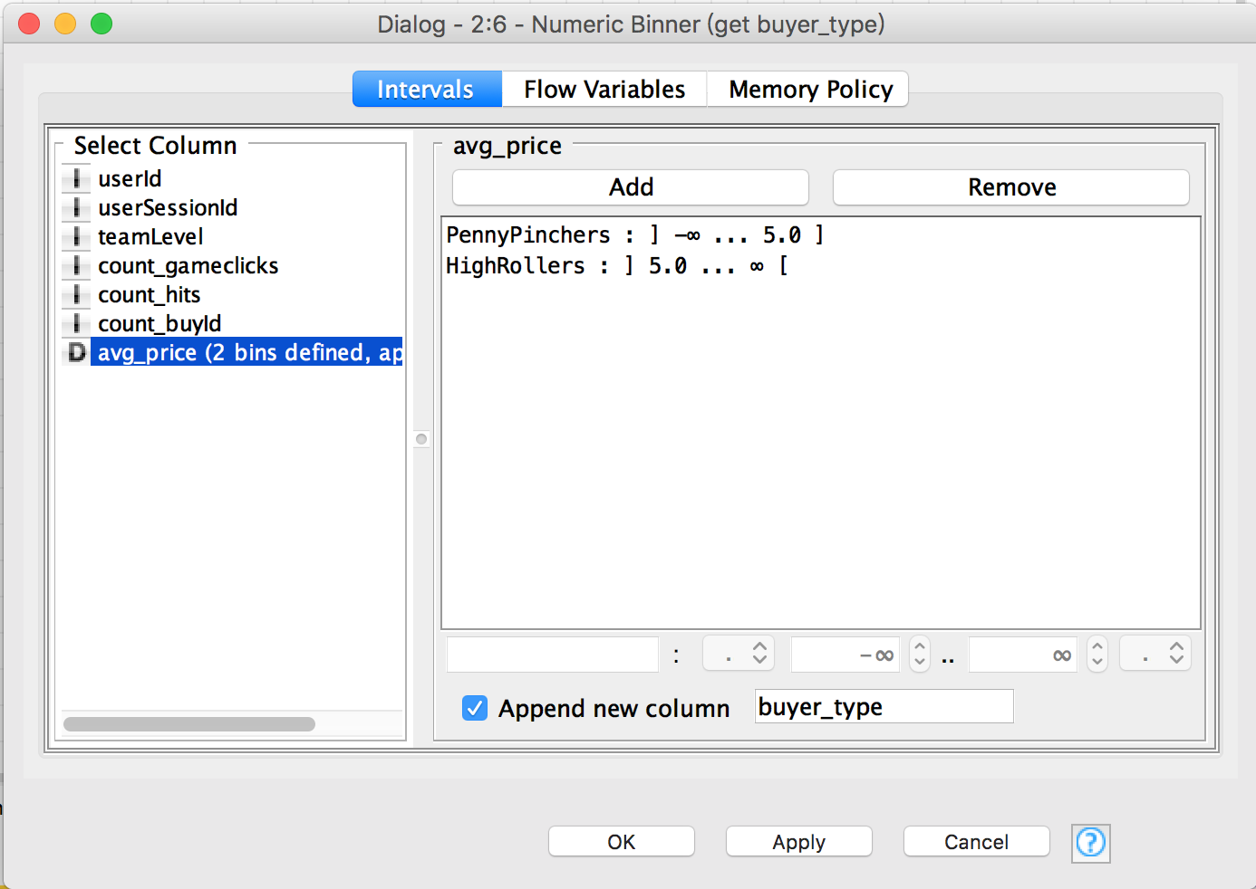

**The column of avg_price represent average per orders of a user. If avg_price greater than 5, then the user is HighRollers. If avg_price less than or equal 5, then the user is PennyPinchers.**

The creation of this new categorical attribute was necessary because.

**The task is classifying users as HighRollers or PennyPinchers, we need categorial variate, instead of continuous variate.**

Attribute Selection

The following attributes were filtered from the dataset for the following reasons:

|  |  |
| --- | --- |
| **Attribute** | **Rationale for Filtering** |
| userID | It is uniquely user id, has no sense to classify. |
| userSession | It is uniquely user session id, has no sense to classify. |
| avg-price | The target label derived from it |